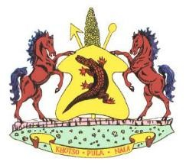
Lesotho permit number…………………………………
VETERINARY HEALTH ATTESTATION FOR CHICKEN MEAT
I……………………………………………………………………………………………………………. the undersigned veterinary/official authorized by the Director of Veterinary Services in ………………. attest the following:
- The chicken meat was derived from birds which were hatched , reared and slaughtered in ……………………………
- The birds must have originated from farms not under any veterinary restrictions for any disease to which the avian species are susceptible;
- Originate from an area free from New Castle Disease or any contagious diseases;
- The birds were slaughtered and processed at an abattoir with approved export slaughter and processing facilities. The chicken meat must have been inspected by an authorized meat inspectors and found fit for human consumption;
- All packaging /wrapping must bear the official inspection stamp of the slaughter plant/ processing facility;
- The vehicle transporting meat must conform to acceptable standards of cleanliness, construction, maintenance and is equipped with a continuous registering thermograph;
- The chicken meat was loaded and sealed by authorized officials and the seal number indicated on the International veterinary certificate:

Seal No………………………………………………………………………………….

Vehicle No……………………………………………………………………………..

- The exporter/importer has been informed to undertake to inform the government veterinary officials nearest to the point of destination, so that she/he could unseal and check the consignment before it is disposed of in any way.
- The permit is valid for 30 days from date of issue and is for one consignment only.

Signed at……………………………………………………………………… On date………………………………………………………………………
______________________________________________
Authorized Veterinary /Official
Name in print…………………………………………………………………..
Designated Rank……………………………………………………………….
Address…………………………………………………………………………….. Official Stamp

